Catherine E. Pugh Room 250
Mayor City Hall
Baltimore, MD 21202

PRIVILEGED AND CONFIDENTIAL
M E M O R A N D U M: March 10th, 2017

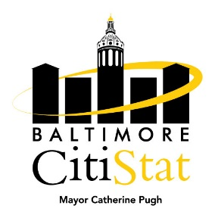
TO: The Honorable Mayor Catherine E. Pugh
Peter Hammen, Chief Operating Officer
Tisha Edwards, Chief of Staff
Jim Smith, Chief of Strategic Alliances
Terry Hickey, Mayor’s Office of Human Services
Sameer Sidh, Director of CitiStat

FROM: CitiStat Team

SUBJECT: Homelessness Stat Meeting Summary Briefing

Making Progress

- Homeless Outreach Team. The Baltimore City Police Department Homeless Outreach (HOT) Team is made up of 3 officers who conduct street outreach to homeless individuals in encampments, as well as responding to calls for service. The Team’s roles include developing personal relationships with homeless individuals, assisting homeless individuals with getting official forms of identification for the purposes of connecting them to services and benefits, and transporting these individuals to and from shelters, appointments, and elsewhere. The panel discussed the HOT Team’s needs, as well as how to better capture outreach data going forward.

Needs Improvement

- Bed Utilization and Process Mapping. The Housing Authority for Baltimore City (HABC) distributes Permanent Supportive Housing vouchers to homeless ex-offenders, chronically homeless individuals and families, as well as homeless veterans via the VASH (Veterans Affairs Supportive Housing) Program. Permanent Supportive Housing refers to a program designed to provide housing (project and tenant-based) and supportive services on a long-term basis. The table below was taken from the Baltimore City 2016 Housing Inventory Count; data was collected on January 31st, 2016. The panel discussed methods to increase bed utilization.

